Global Education for Brazilian students

Brazilian students are traveling all across the world to pursue their education as part of a new, innovative program for students.

Caio Ribeiro De Paula, a forestry major studying at Colorado State University (CSU) is one of those student who got the opportunity to be a part of this program. “I was a little bit afraid, because I thought it would be difficult to make friends. But I really like it here, I have friends from all different countries,” he stated.

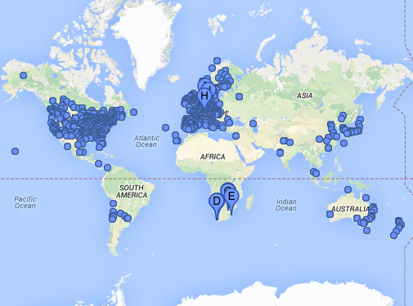
The adjustment didn’t take long for Caio after he received an education in English and stayed in the United States. The Natural Resources Program at CSU if one of the top in the country, and Caio feels fortunate to come here and study.

The Ciência sem Fronteiras (Science without Borders) program, started in 2011, gives students in Brazil a unique opportunity to study in other countries.

Brazil took a huge investment in funding in upwards of 101,000 students to study abroad. They branched out to other countries and asked for participations, and over 30 countries responded with a wide range of universities.

The United States quickly picked up the program, known at the Brazil Scientific Mobility Program (BSMP). Nationally, institutions apply for students to come here.

Courtney Beardmore, International Student and Scholar Advisor at CSU stated, “CSU submitted an application to be a host institution.

We didn’t have many Brazilian students prior to getting connected to this program, so it was a good opportunity for us to branch out and get a more diverse group of international students.

The students are already working on their degrees at a university in Brazil, and the program has fairly high standards for acceptance, so we get some of the best and brightest students in Brazil through this program.”

BSMP is a scholarship program that provides money to undergraduate and graduate students studying science, technology, engineering, or mathematics (STEM). Students wanting to study abroad apply for the programs, choosing their top three countries, once accepted and given a country of study, students then choose their top three participating universities.

They take the TOEFL exam for language comprehension, and begin their studies. For a year they get to live on a different campus, study with a different group of students, and be complete immersed in a new culture.

“Brazil is paying for everything. The majority of the population cannot afford an exchange program. This is a big opportunity, it’s huge,” stated Tales Costa Silva, another Brazilian student studying abroad.

This program is part of a greater movement in Brazil to increase scientific advancement and initiatives in research and technology. The Ministry of Education in Brazil pays for the great majority of the program, while private donors supplement the rest. But it was not implemented without criticism.

“There are people who agree with the program and there are people who disagree,” said Silva. “The Ministry of Education gives us the opportunity to study here, but they don’t have control over what we are doing here, whether we are studying or not.”

Under their J-1 Visa regulations, students are able to studying in another country for a year, but must return to their home country and stay for two years. During the students study, they must complete an internship before they go back from their host country.

“I know Brazilian students that are at NASA, Boeing, MIT, all over. And I think they are doing a really good job,” said Silva. Silva, a biomedical science major at CSU, feels his opportunity has been valuable.

He’s participated in his classes, but also been involved in his residence hall, participating in Hall Counsel, a student government within the residence halls.
This program will only continue for Brazilian students, as the program was renewed by the Ministry of Education again this year.

Nicole Barton

